Asymmetric DCC correlation: NZDUSD and USDJPY
Method 10 / GARCH(1,1) + Cappiello-Engle-Sheppard ADCC / Alpari D1 full available history

Study setup
Logical pair: NZDUSD , USDJPY
Broker symbols: NZDUSD_i , USDJPY_i
Snapshot: 2026-11-03_majors_alpari_D1
Timeframe: D1
Matched return window: 1999-01-05 to 2026-11-02 (UTC bar dates)
Matched return count n: 7185
Dropped unfinished last bar dated 2026-11-03 UTC after a tick-volume check against the prior complete day.
NZDUSD GARCH(1,1): mu=0.000006, omega=0.004848, alpha=0.040259, beta=0.950893
USDJPY GARCH(1,1): mu=0.000111, omega=0.005037, alpha=0.052325, beta=0.934935
ADCC: a=0.043157, b=0.915926, g=0.037462, a+b+g/2=0.977814
Nested DCC (g=0): a=0.041274, b=0.941046
Negative shock: n = min(z, 0) in broker quote direction (not inverted)
Burn-in ignored in path summaries and chart: first 60 updates
Complete matched rows (Excel): NZDUSD-USDJPY_ADCC_D1.xlsx
Complete matched rows (HTML table): NZDUSD-USDJPY_ADCC_D1_data.html

Method carried forward
Asymmetric DCC extends Engle DCC with an extra term on joint negative standardised shocks. Each matched daily log return of close, ln(close_t / close_t-1), is first filtered by a constant-mean GARCH(1,1). Then z = residual / sigma and n = min(z, 0). The Cappiello-Engle-Sheppard recursion uses A = (1-a-b) Q_bar - g N_bar with N_bar = mean(n n'). Quotes are not inverted, so a negative shock is a negative log return in the broker quote. Nested symmetric DCC (g = 0) is fit on the same z path for comparison. Constraints: a,b,g >= 0 and a + b + g/2 < 1. Path summaries ignore the first 60 updates. The headline is latest ADCC rho. Pearson r is a side check only. This is not a cause, lead, or trading signal.

Results
Latest ADCC rho: -0.189283
Latest nested DCC rho: -0.194392
Post-burn-in ADCC path (n=7125): mean=-0.257188, median=-0.306839, min=-0.640420, max=0.750368, std=0.228991
Share of post-burn-in days with |rho| >= 0.4: 32.32%; |rho| >= 0.7: 0.08%
Same-sample Pearson r: -0.133568
ADCC minus r: -0.055715
ADCC minus nested DCC: 0.005109

Conclusion
Over 7185 matched daily log-return rows for NZDUSD and USDJPY (broker quote directions unchanged), latest ADCC rho is -0.1893 (negative, weak conditional linear link in this sample) with fitted a=0.0432, b=0.9159, g=0.0375. Nested symmetric DCC latest rho is -0.1944 (ADCC minus DCC = 0.0051). After a 60-day burn-in, path mean is -0.2572 and std is 0.2290. Same-sample Pearson r is -0.1336 (ADCC minus r = -0.0557). This does not establish cause, lead-lag, or a lasting trading rule.

Charts
Daily closes

Daily log returns
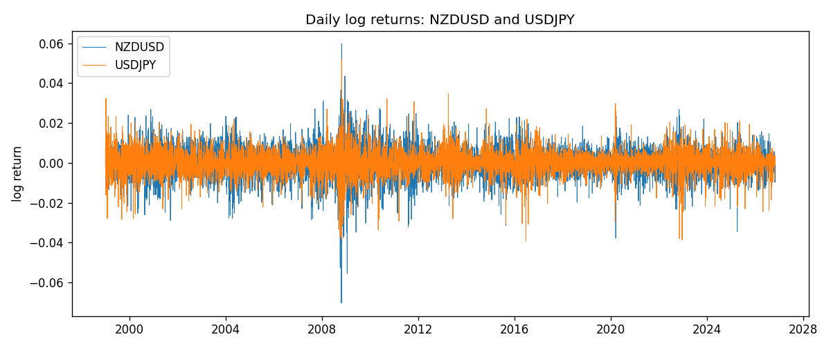
ADCC rho path with nested DCC and Pearson r
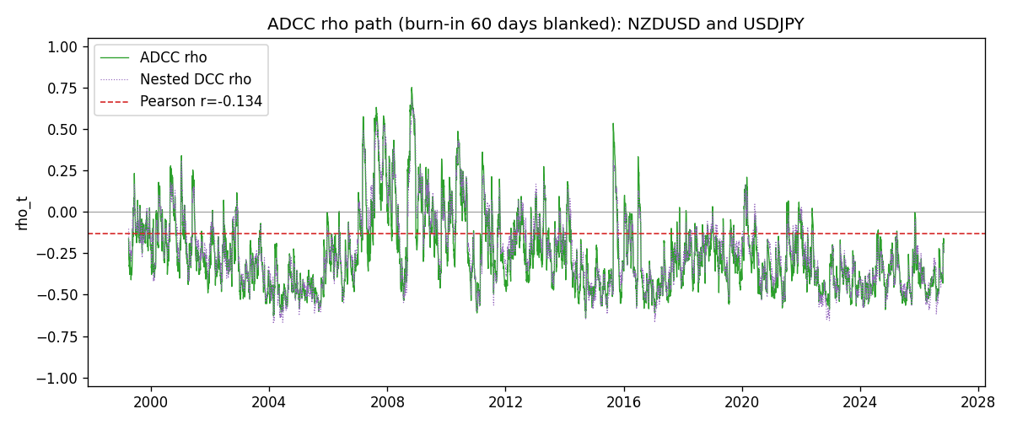

Data report
Every matched row that entered the ADCC recursion is stored in the sibling Excel workbook named NZDUSD-USDJPY_ADCC_D1.xlsx. Embedding all rows as a Word table is impractical at this length; the Word file holds the column list, column summaries, and the first and last 15 matched rows.
Columns: time, NZDUSD_open, USDJPY_open, NZDUSD_high, USDJPY_high, NZDUSD_low, USDJPY_low, NZDUSD_close, USDJPY_close, NZDUSD_tick_volume, USDJPY_tick_volume, NZDUSD_spread, USDJPY_spread, NZDUSD_real_volume, USDJPY_real_volume, NZDUSD_log_return, USDJPY_log_return, NZDUSD_sigma, USDJPY_sigma, NZDUSD_z, USDJPY_z, NZDUSD_n, USDJPY_n, q11, q22, q12, rho_adcc, rho_dcc
Column summaries (matched calculation rows)
column | count | mean | std | min | 25% | 50% | 75% | max
NZDUSD_open | 7185 | 0.65641035 | 0.10820414 | 0.3913 | 0.59133 | 0.6684 | 0.72491 | 0.88218
USDJPY_open | 7185 | 113.80829 | 19.224285 | 75.693 | 104.39 | 110.98 | 120.695 | 163.824
NZDUSD_high | 7185 | 0.6603272 | 0.1086977 | 0.3961 | 0.59474 | 0.672 | 0.72936 | 0.88421
USDJPY_high | 7185 | 114.30556 | 19.28576 | 76.001 | 104.868 | 111.439 | 121.26 | 163.978
NZDUSD_low | 7185 | 0.65272421 | 0.10779902 | 0.3897 | 0.58806 | 0.66417 | 0.72098 | 0.87988
USDJPY_low | 7185 | 113.28523 | 19.152023 | 75.402 | 103.88 | 110.53 | 120.17 | 163.628
NZDUSD_close | 7185 | 0.65648647 | 0.10820164 | 0.3907 | 0.59157 | 0.6684 | 0.72502 | 0.8822
USDJPY_close | 7185 | 113.8211 | 19.239467 | 75.811 | 104.38 | 111.015 | 120.69 | 163.851
NZDUSD_tick_volume | 7185 | 68717.699 | 123140.61 | 16 | 5585 | 33899 | 58511 | 1127682
USDJPY_tick_volume | 7185 | 106344.18 | 179438.14 | 149 | 9948 | 53202 | 92889 | 1803508
NZDUSD_spread | 7185 | 30.280167 | 25.649381 | 0 | 9 | 17 | 40 | 80
USDJPY_spread | 7185 | 20.273626 | 17.623751 | 0 | 6 | 11 | 30 | 50
NZDUSD_real_volume | 7185 | 1.6703703e+10 | 8.4983725e+10 | 0 | 0 | 0 | 0 | 2.705649e+12
USDJPY_real_volume | 7185 | 3.4781051e+10 | 1.6093614e+11 | 0 | 0 | 0 | 0 | 3.8834203e+12
NZDUSD_log_return | 7185 | 1.284e-05 | 0.0076404 | -0.07027433 | -0.00425236 | 0.00022967 | 0.00458145 | 0.05966839
USDJPY_log_return | 7185 | 4.789e-05 | 0.00620418 | -0.03908203 | -0.00320044 | 0.00011802 | 0.00340223 | 0.05184024
NZDUSD_sigma | 7185 | 0.00728456 | 0.0021657 | 0.0043892 | 0.0059587 | 0.00670471 | 0.00803321 | 0.02515282
USDJPY_sigma | 7185 | 0.00599026 | 0.00174461 | 0.00337121 | 0.00476426 | 0.00569366 | 0.00679532 | 0.01886186
NZDUSD_z | 7185 | -0.00211584 | 1.0000798 | -5.6242185 | -0.6301753 | 0.03242869 | 0.64783656 | 4.2189456
USDJPY_z | 7185 | -0.0090857 | 1.0002805 | -6.5339999 | -0.56309654 | 0.00116815 | 0.58029409 | 7.1076829
NZDUSD_n | 7185 | -0.38936397 | 0.61537999 | -5.6242185 | -0.6301753 | 0 | 0 | 0
USDJPY_n | 7185 | -0.37428678 | 0.62399638 | -6.5339999 | -0.56309654 | 0 | 0 | 0
q11 | 7185 | 1.0003452 | 0.32077458 | 0.48594922 | 0.80148126 | 0.93133633 | 1.1096302 | 4.2219437
q22 | 7185 | 1.0008866 | 0.39098036 | 0.40099084 | 0.75580443 | 0.90810053 | 1.1258533 | 4.1512728
q12 | 7185 | -0.22771576 | 0.27732046 | -1.1659347 | -0.38281324 | -0.2666951 | -0.13784411 | 2.093027
rho_adcc | 7185 | -0.2569274 | 0.22840245 | -0.64042033 | -0.42593345 | -0.30638701 | -0.14698633 | 0.75036822
rho_dcc | 7185 | -0.23911883 | 0.22528521 | -0.67529948 | -0.40362058 | -0.27287882 | -0.11699924 | 0.67822915
First 15 matched rows (selected columns)
time | NZDUSD_log_return | USDJPY_log_return | NZDUSD_z | USDJPY_z | NZDUSD_n | USDJPY_n | q11 | q22 | q12 | rho_adcc | rho_dcc
1999-01-05 | -0.0018597736 | -0.00017868311 | -0.31721142 | -0.025788637 | -0.31721142 | -0.025788637 | 1 | 1 | -0.22757696 | -0.22757696 | -0.22757696
1999-01-06 | 0.0020455609 | 0.0075660159 | 0.35226489 | 0.68525608 | 0 | 0 | 0.94509151 | 0.93706438 | -0.22186723 | -0.23576075 | -0.22673097
1999-01-07 | 0.0062963171 | -0.012851583 | 1.1029153 | -1.2136623 | 0 | -1.2136623 | 0.89204264 | 0.89963173 | -0.20687935 | -0.23093616 | -0.21310989
1999-01-08 | -0.00055396548 | -0.0047719894 | -0.097466665 | -0.45346784 | -0.097466665 | -0.45346784 | 0.89059525 | 0.96382979 | -0.2613374 | -0.2820728 | -0.25898957
1999-01-11 | 0.010290425 | -0.016195423 | 1.8213185 | -1.5536657 | 0 | -1.5536657 | 0.83753859 | 0.92045932 | -0.24988563 | -0.28460109 | -0.25515935
1999-01-12 | -0.0053157489 | 0.032310364 | -0.89874282 | 2.9717416 | -0.89874282 | 0 | 0.93133633 | 1.0587603 | -0.36508131 | -0.36765249 | -0.34126755
1999-01-13 | -0.0099742238 | 0.0081373171 | -1.6878011 | 0.62577273 | -1.6878011 | 0 | 0.93920716 | 1.3719587 | -0.46373497 | -0.40852498 | -0.37975924
1999-01-14 | -0.00018564931 | 0 | -0.031196936 | -0.0088279399 | -0.031196936 | -0.0088279399 | 1.1109531 | 1.2945974 | -0.48441135 | -0.40392347 | -0.39100266
1999-01-15 | -0.00074294208 | 0.0055343401 | -0.12417858 | 0.44590815 | -0.12417858 | 0 | 1.0386828 | 1.2068466 | -0.45774592 | -0.40884339 | -0.38837898
1999-01-18 | -0.0018597736 | 8.7600193e-05 | -0.3149384 | -0.0019630327 | -0.3149384 | -0.0019630327 | 0.97365317 | 1.135048 | -0.43573423 | -0.41448843 | -0.38634929
1999-01-19 | 0.0018597736 | -0.0056219403 | 0.31792433 | -0.49950085 | 0 | -0.49950085 | 0.92084391 | 1.0607051 | -0.41313361 | -0.41802301 | -0.38274445
1999-01-20 | 0.0040793678 | -0.0053879917 | 0.7095946 | -0.49109473 | 0 | -0.49109473 | 0.86884038 | 1.0127266 | -0.39933639 | -0.42571876 | -0.38385646
1999-01-21 | 0.0040627941 | 0.0084664056 | 0.7117512 | 0.76497579 | 0 | 0 | 0.83857735 | 0.96811042 | -0.3948849 | -0.43826472 | -0.38954464
1999-01-22 | -0.012051689 | 0.0060412564 | -2.1302267 | 0.55134146 | -2.1302267 | 0 | 0.81099093 | 0.93305706 | -0.35227082 | -0.40496228 | -0.35375154
1999-01-25 | -0.0035504102 | -0.0073594164 | -0.58623075 | -0.71060326 | -0.58623075 | -0.71060326 | 1.1296965 | 0.88881463 | -0.38742395 | -0.38663393 | -0.36371286
Last 15 matched rows (selected columns)
time | NZDUSD_log_return | USDJPY_log_return | NZDUSD_z | USDJPY_z | NZDUSD_n | USDJPY_n | q11 | q22 | q12 | rho_adcc | rho_dcc
2026-10-13 | 0.0047326165 | -0.0018932826 | 0.95927078 | -0.41179908 | 0 | -0.41179908 | 0.74108124 | 0.65522777 | -0.27492377 | -0.39453291 | -0.36891191
2026-10-14 | -0.0037306483 | 7.5800166e-05 | -0.75537864 | -0.0073322979 | -0.75537864 | -0.0073322979 | 0.73954176 | 0.63489592 | -0.28294098 | -0.41291745 | -0.37607914
2026-10-15 | 0.0047634855 | -0.0018524319 | 0.96479506 | -0.41977022 | 0 | -0.41977022 | 0.74441946 | 0.60260663 | -0.27278957 | -0.40728831 | -0.36609167
2026-10-16 | 0.0057501001 | -0.00037976126 | 1.1600685 | -0.10666373 | 0 | -0.10666373 | 0.74305804 | 0.58723321 | -0.28141629 | -0.42602252 | -0.3742783
2026-10-19 | 0.0018917133 | 0.0034946841 | 0.37618921 | 0.75109762 | 0 | 0 | 0.75971808 | 0.55986397 | -0.27717967 | -0.42500485 | -0.36393718
2026-10-20 | 0.0037199341 | -0.0022546642 | 0.75000922 | -0.52790691 | 0 | -0.52790691 | 0.72300635 | 0.55822532 | -0.25576501 | -0.40259215 | -0.33680657
2026-10-21 | 0.0030923331 | -0.00032883504 | 0.62536318 | -0.099395036 | 0 | -0.099395036 | 0.7075499 | 0.55484487 | -0.26543216 | -0.42363245 | -0.34893016
2026-10-22 | -0.0033035227 | -0.0085942669 | -0.67514932 | -2.0071831 | -0.67514932 | -2.0071831 | 0.68599437 | 0.53007788 | -0.25988183 | -0.43096877 | -0.34558507
2026-10-23 | 0.0030929853 | 0.00035080446 | 0.63310489 | 0.051093946 | 0 | 0 | 0.68612139 | 0.83139083 | -0.14286571 | -0.18915809 | -0.22792319
2026-10-26 | -0.0028993932 | 0.0041238746 | -0.59964978 | 0.87309338 | -0.59964978 | 0 | 0.6667879 | 0.78268983 | -0.14354142 | -0.19869574 | -0.22348552
2026-10-27 | -0.00026399852 | 0.0027651658 | -0.056121127 | 0.57787174 | -0.056121127 | 0 | 0.66077042 | 0.77086868 | -0.16815107 | -0.23560481 | -0.24576514
2026-10-28 | -0.0097283914 | -0.00095679538 | -2.0522583 | -0.23524578 | -2.0522583 | -0.23524578 | 0.62652402 | 0.74155491 | -0.16949659 | -0.24866831 | -0.24490648
2026-10-29 | 0.00062190714 | -0.00038043789 | 0.12150584 | -0.11035249 | 0 | -0.11035249 | 0.93444862 | 0.70475555 | -0.13040801 | -0.16069683 | -0.19201989
2026-10-30 | 0.00019537668 | -0.0010596481 | 0.037925023 | -0.268198 | 0 | -0.268198 | 0.87757635 | 0.66757032 | -0.13410578 | -0.17520904 | -0.19342899
2026-11-02 | -0.0025962955 | 0.0026438521 | -0.52906278 | 0.59077391 | -0.52906278 | 0 | 0.82491045 | 0.63832854 | -0.13735296 | -0.18928338 | -0.19439207

